2023-2024
Parent Handbook
Welcome to Renovation Parent’s Day Out! We are so excited that you have chosen our program for your child.
Our Purpose and Mission
To minister to the families in our community by providing their children with a positive, Christian learning environment where they can be nurtured spiritually, academically, emotionally, and physically.
Daily Activities
Each classroom will follow a daily schedule specially created for their age group. Along with the curriculum, every child will also participate in a variety of learning opportunities such as:
- A Bible story or verse.
- Reading books, stories, and the occasional educational video.
- Learning to share, take turns, work together, and play with others.
- Work on alphabet and phonetic sounds, counting, shapes, colors, etc.
- Practicing good hygiene and cleanliness habits.
Program Hours
Our center is open Mondays and Wednesdays from 9am to 2pm. Drop-off will begin at 8:45 am, doors will not open until this time. Drop-off ends at 9:15, please have your children here before 9:15 to avoid disruptions to the classroom. Pick-up will begin at 1:45 and your child must be picked up by 2:05 at the latest. There will be a fee of $10 for the first 5 minutes after 2:05 and $5 for each 5 minutes after that.
Tuition and fees
Tuition will be $200 a month, due on the first operating day of the month. Tuition will be considered late on the 10th day of the month and a $35 late fee will be added. If tuition is not paid by the 15th of the month your child(ren) will not be allowed in attendance until tuition has been paid. A $25 fee will be added for any returned checks. Please speak with the director if you have further questions.
For siblings, the first child is full price, and each additional child will receive 10% off.
There is a $10 registration fee per child. Also, a supply fee of $50 per child is due at registration, and at the beginning of each fall, spring, and summer sessions going forward. Registration and supply fees are non-refundable.
Requirements for Admission
The following forms must be completed and turned in, along with the registration and supply fee before your child’s first day.

- Enrollment Form
- Medical Release
- Picture Permission Form
- Handbook Agreement
All children must be able to walk independently and be able to feed themselves lunch and a snack to a reasonable degree. We can give out bottles, but do not have a way to warm them up, if your child still needs a bottle, they must be able to hold their own bottle while sitting in a chair at the table.
Withdrawal
We ask that you give us at least 2 weeks’ notice if you are going to withdraw your child. This allows us time to fill your child’s spot. With advanced notice, we can pro-rate your tuition if your child(ren) will not be in attendance the full month, however all fees and tuition are non-refundable.
Security
Renovation PDO takes every precaution to protect your children. We know that you will find our program to be a wonderful, loving, and safe place to leave your child(ren) to grow and learn about Jesus. Our church and program take very seriously the trust you have given us when enrolling your child. All our teachers and staff have been through thorough interviews and background checks before being allowed in a classroom. All outside doors will remain locked during business hours. The entrance to the PDO program has automatically locking doors and you must be buzzed in to enter. We also have security cameras at each entrance, in the hallways, and in every classroom for added safety and peace of mind.
If someone other than yourself will be picking up your child, please be sure to add them to your authorized pick-up list. You can also call the director the day of and let her know who will be picking your child(ren) up. We will ask for a driver’s license from any new person picking up and they will be escorted to and from the child’s classroom by the director.
Discipline
Discipline and guidance will be caring and consistent. Our first method will be positive guidance, encouraging the child in a positive manner so that he/she may redirect themselves toward desired behavior.
If the behavior is consistent, we will place the child in time-out, the general guidance is one-minute times the age of the child (Example: 1 year= 1 minute, 4 years= 4 minutes). If the behavior is continually disruptive to the class, we will schedule a conference with the director, teacher, and parent. If the child hurts himself, another child or staff member or destroys church property an incident report will be completed. Two incident reports constitute a pattern of undesirable behavior, and a conference will be scheduled. If the behavior continues the child will be sent home for the day. Each issue will be handled on an individual basis, along with suspension or dismissal from the program. Dangerous behavior exhibited on the part of a child towards themselves or others (including attempting to continually run away from their teacher/classroom) will not be tolerated. Any property damage or physical liabilities that result from the child’s destructive actions while on the church campus are solely the parent’s responsibility.
Supplies
Please be sure to label all items clearly with the child’s first and last name. If an item is not labeled, we will label it for you (with tape and/or sharpie)
  - Diapers/wipes (if needed)
  - Water bottle/sippy cup
  - 2-3 changes of correctly sized, weather appropriate clothes
  - Lunchbox with a healthy, cold lunch and snack
  - School-size backpack or diaper bag
  - Nap mat and blanket (pillow, stuffed animal, or anything else to help them sleep)
Clothing
Please send your child to school in play clothes and closed-toe shoes. We will use paint, markers, glue and other messy craft items throughout the year, they will also play outside in grass and dirt. While we will do our best to keep them clean, they will get messy occasionally and we don’t want expensive clothing items to be ruined. We will not be responsible for replacing or drycleaning clothing items that get messy during their time in the program. Please send a change of clothes in their bag.
Health and Illness
Children are not allowed in the classroom if they show obvious signs of illness, including fever of 100.4 or higher, vomiting, diarrhea, and/or severe cough. If you have siblings (even school-aged) that are disqualified from attending that day, then all children in the family are disqualified. Children may not return until twenty-four after the child is temperature free, without the aid of medication. Other symptoms will be on a case-by-case basis and will usually require a doctor’s note stating they are free to return.
We cannot admit any child or staff member exhibiting any of the following symptoms:
- Fever of 100.4 or higher
- Cough
- Shortness of breath or difficulty breathing
- Chills or repeated shaking with chills
- Muscle Pain
- Headache
- Sore throat
- New loss of taste or smell

- Children with temperatures exceeding 100.4 will be excluded from the group, and parent/guardian must pick up within 30 minutes of being notified. A fee of $10 per 5 minutes late will be charged if the child is not picked up within 30 minutes
.
If your child is diagnosed with a communicable disease, such as RSV, flu, chicken pox, pneumonia, Covid, HFM, etc., you must notify the director immediately. Your child must remain home until cleared by a doctor to return and the director will notify parents if their child may have been exposed.
Potty Training
We are happy to assist in your efforts of potty training, however we ask that your child is consistently using the potty with a dry diaper or pull-up before sending them in underwear for sanitary reasons. We will never force a child to use the potty. Please bring your child to class in a new, dry diaper or pull-up every morning.
Nap Time
All classrooms have a scheduled nap/rest time. Naps/Rest are important for appropriate development for all age groups in our program. Children will not be required to sleep, but they must lay quietly on their mats and not disturb others. A quiet activity can be given to the child on their mat to assist in this. If a child is continually disruptive during nap time, they may be asked to be picked up early. No adjustment to tuition will be made for the early pick-up time.
Substitute Teachers
Substitute teachers will be needed from time to time. If you are interested and wish to be included on the sub list, please call the director for more information! We pay at the end of the shift, or we can take that amount off your child’s next month’s tuition.
Holidays and Inclement Weather
We will follow the same school schedule as Waco ISD and will observe the same holidays. If the WISD closes due to inclement weather, we will also close. Please tune to KWTX (News Channel 10) for weather changes. If WISD has a late start due to weather, we will be closed. PDO will not have make-up days due to bad weather nor will tuition be pro-rated. The Director has the right to close on any day at her discretion, we will try to avoid this, but sometimes situations will arise that make closures necessary. We will try to give as much notice as possible if this were to occur and appreciate your understanding of this matter. Check our Facebook page and the Church Center app for notices regarding closures.
Facebook
Please be sure to find and “like” our Facebook page. We post pictures, videos, updates, and notices of closures on our page. Facebook.com/RenovationPDO
Personal Property
Renovation Church and Renovation PDO are not liable or responsible for any personal items brought into the building. If any items turn up lost, stolen or damaged it is the sole responsibility of the parents to replace them. Renovation PDO will not replace or reimburse for lost personal items.
Modification Clause
This agreement may be modified whenever any of the circumstances covered by the agreement change. Such modifications may only be made in writing and must be signed and dated by the parties involved in order to be binding and effective. Oral modifications are not binding under this agreement and shall not be enforceable.
Termination of Agreement
This agreement shall be terminated if any one or more of the following occur:
- The school year has come to an end.
- Serious illness of the child prevents attendance.
- The child’s financial account becomes delinquent.
- Failure of the parent/guardian to honor the obligations listed in this agreement or any other rules, regulations, or manuals provided by the center.
- The center determines that it is unable to meet the needs of the child.
- The center determines that it is not in the best interest of the center or other children at the center to have the child in attendance.
- Failure of the parent/guardian to cooperate with the center director.
- A child is injuring other students through rough behavior more than 2 times a week on a regular basis.

If you have any questions, please feel free to reach out at any time.
Amy Wells
Director
Renovation PDO

I have reviewed the Renovation Parent’s Day Out Handbook for 2022-2023. I understand that the handbook contains information that my child and I may need during the school year. I also agree to abide by the rules and regulations laid out. If I have any questions regarding this handbook, I should direct those questions to the Director, Amy Wells at 254-315-0074 or amyw@rcwaco.com

Name of Child ___________________________________
Parent’s Name Printed ___________________________________
Parent’s Signature ___________________________________
Date ___________________

Church Center!
With our new system we will no longer be able to send text messages so our main form of communication will come from our church app. Please download the app and join the Renovation PDO group as soon as possible and be sure to turn on notification so you will know when a message comes in. Also, please do not respond to any messages on the app as that will be sent to everyone in the group. You are always welcome to text or call me directly for questions. The app is called Church Center. Once downloaded it will ask for your phone number, which is already associated with your account and will open for you.
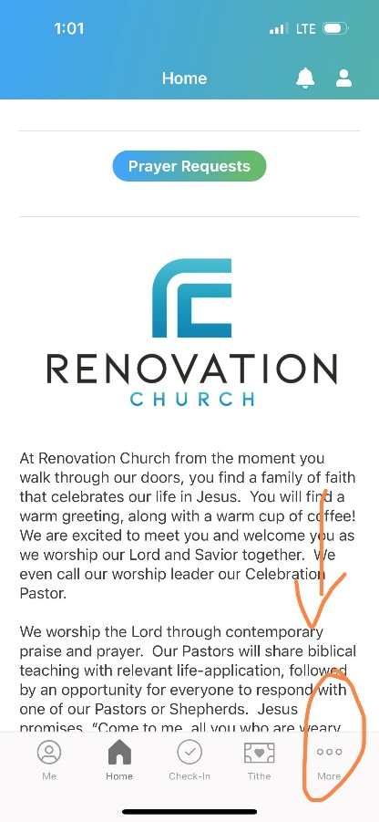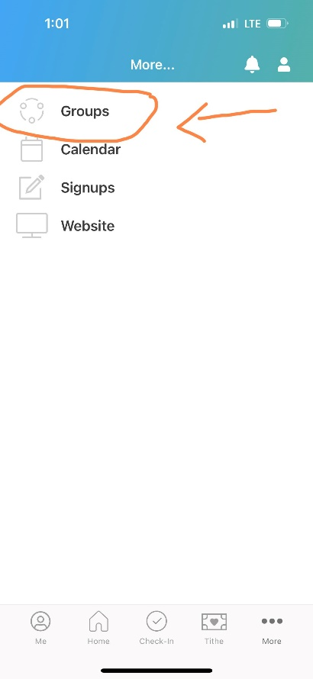
^Click on “More” ^Click on “Groups” ^This is where messages will be

Tuition will now be paid ONLY through the App. There will be no direct link from the church website anymore. I am providing visuals on the step-by-step process to make your tuition payment (and registration and supply fees as well).
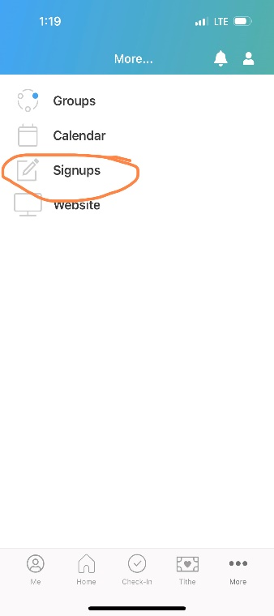
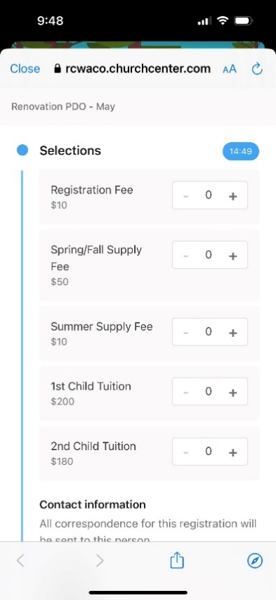
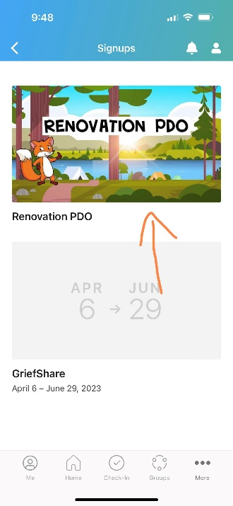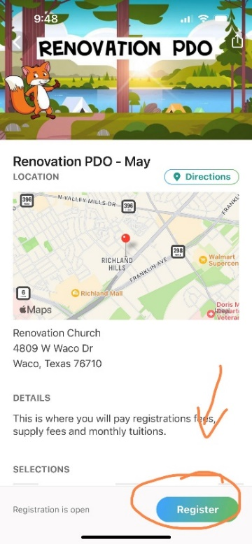O
From this screen you will add which payment you need to make. You can make multiple payments at the same time, just use the plus and minus button to add how many of each item you need.
From the app tap the word “MORE” on the bottom right of the screen, from there you will tap the “signups” button.
Once you are on the Renovation PDO page you will tap on the button “Register”.
One you tap “signups”, tap on the Renovation PDO button.

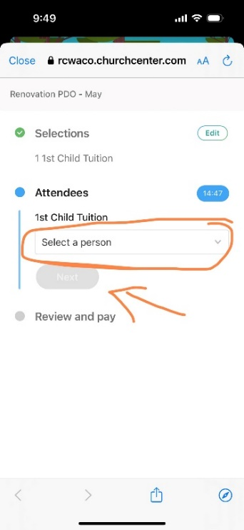
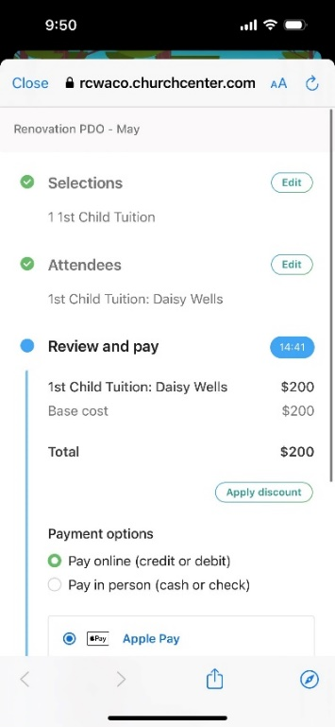
After you select “Next” it will tell you the total and you can select how you would like to pay.
On the next screen you will be prompted to select which child you are making each payment for. Your children will already be pre-programmed into your account. Then click “Next”.

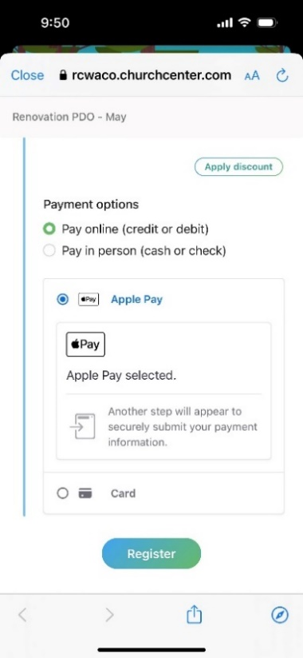
You will enter in your card information or select Apply Pay and complete your payment by selecting “Register” at the bottom. Congratulations! Your payment has now been completed!

